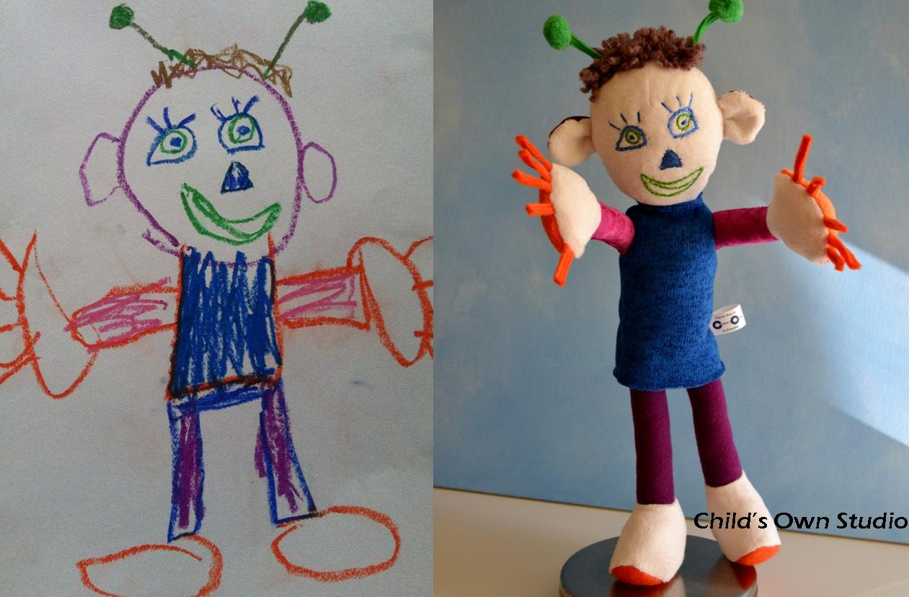

Children’s Art in Clay
For this project you will be creating a sculpture “in the round” using all techniques shown so far. This sculpture will be a 3-D replica of an art work from the elementary art show. Please be accurate, imaginative, and structurally eloquent.
Questions for Success
Does your sculpture contain all elements of the art work? (Language of Art)
Does your sculpture stand on its own and show ingenuity? (Technique)
Can you explain which techniques you used? (Critique)
Have you analyzed the work of two peers and offered helpful feedback? (Critique)
Is your piece refined and professionally rendered? (Technique)

Children’s Art in Clay
For this project you will be creating a sculpture “in the round” using all techniques shown so far. This sculpture will be a 3-D replica of an art work from the elementary art show. Please be accurate, imaginative, and structurally eloquent.
Questions for Success
Does your sculpture contain all elements of the art work? (Language of Art)
Does your sculpture stand on its own and show ingenuity? (Technique)
Can you explain which techniques you used? (Critique)
Have you analyzed the work of two peers and offered helpful feedback? (Critique)
Is your piece refined and professionally rendered? (Technique)

