Third Culture Kid Tea Party
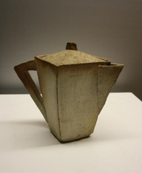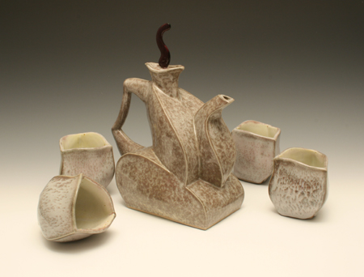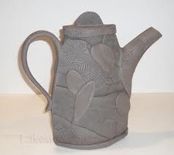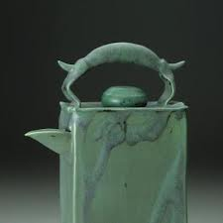
Michael Wein Etrapakova Lakeside Pottery A Slab of Clay (FB)

Emphasized Standards:
1-Creating 4-Technique 3-Self Expression 5-History & Culture

Introduction:
While creating a slab teapot, proper technique is essential in creating a piece that will make it through the firing process! You will be creating a unique teapot that shows patterned texture, interesting form, and creative ingenuity. You are the designer and your imagination is your only limit.

Ideas Development in Sketchbook:
You must first brainstorm five ideas for your teapot in your sketchbook. There must be a personal connection your own cultures. Those cultures could be the different countries in which you have lived, the country where you were born, the country where your parents are from or the Philippines.You must think in terms of SLAB technique. Then you may print one word document that shows a variety of thumbnail images of teapots, texture, pattern, or anything relevant to your own chosen artist/style/culture.

Performance Task:
You will be creating one unique, properly constructed, personally connected teapot out of clay. This sculpture must show texture, pattern, unique form, and imagination. Colour is not as important here, as you will only use one colour of glaze for the entire piece.

Questions For Success:
- Have you gone through the entire design cycle in order to create a refined and highly original piece of art?
- Is your work high quality, well controlled, and confidently refined?
- Have you sculpted something that shows your concept in a surprising way?
- Are your own “personal cultures” apparent?

