Pencil Drawing From Photo
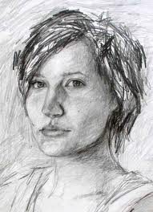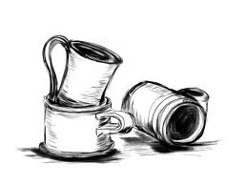

Emphasized Standards: Creating, Language of Art, Technique

Introduction to Performance Task:
In most art projects, we begin with the assignment, the plan, the brainstorm, and then the studio work. For this project we began with some building blocks for the performance task. Creation of a value scale, shading practice, grid puzzle, and pre-test of portrait drawing.
Please answer these in your sketchbook:
- Why is a full range of value so important?
- How does grid drawing help us to draw accurately?
- Can we create a self-portrait that shows all of the elements and principles in a unique and bold way?

- For this project you will use a black and white photo using photo-booth.
- You will have one object in your portrait that symbolizes your home.
- You must take in to account all of the principles while planning your piece.
- Your final piece must be refined, show a full range of value and be realistic.
- You will have four class periods only to create your finished work.

Sketchbook:
1. Answers to above three questions.
2. Brainstorm and Rough draft to show what your final piece will be.

Success Questions:
Have you created something that shows your understanding of shading with pencil and grid drawing? (TECHNIQUE)
During the project did you review, refine, and revise independently? (Creating)
Do you incorporate the principles in order to create something eye-catching and bold? (Language of Art)

